Forever Shaken
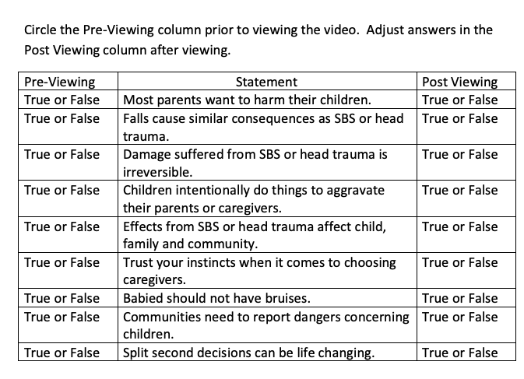

The host of the show discusses some misconceptions and problems about SBS.
#1:
The term shaken implies…

…the truth…

#2: The term baby implies…

…the truth is
…
#3: The term syndrome implies…

…the truth is…

Statistically speaking…

Almost _____ in _____ parents of children under two admit that they or their
partner have shaken a child. This equals _____________________ children in the
United States under the age of 2 times 1% totaling and estimated _____________
children shaken. The above numbers do not include…
Factors that can lead to shaking include…
When a child is shaken, this is what happens… • Head moves like an _____________ • Neck muscles are __________ while their head is ___________ compared
to their body.
• The head goes through a large amount of _______________. • The ___________ hits their _____________ and the back of their will hit
their ____________.

All of this can lead to…

Coping Skill/Strategies include…

Provide two reasons why this video was made.

What is your personal reaction to this video? Explain by writing one solid
paragraph in the space below. Paragraph should be 5 sentences, minimum. Be
sure you are describing your personal feelings/opinions, not just summarizing the
video.

