Names_______________________________________________________________ Date _________________ Pd ______

Harry Potter Genetics – Part 2

Use your knowledge of genetics to answer each question.

- Use the information for Wizard traits in the table below to help you write the phenotype for each genotype provided.

Trait | Dominant | Recessive |  | a. hh _________________  b. Mm ________________  c. FF _________________  d. Bb _________________ | e. mm ________________  f. HH ________________  g. bb _________________  h. Ff _________________
Hair color | Black (H) | Red (h)
Eye color | Brown (B) | Blue (b)
Magic Ability | Muggle (M) | Wizard (m)
Freckles | Freckles (F) | freckleless (f)

- Use the information in the table above to write the genotype(s) for each phenotype below.

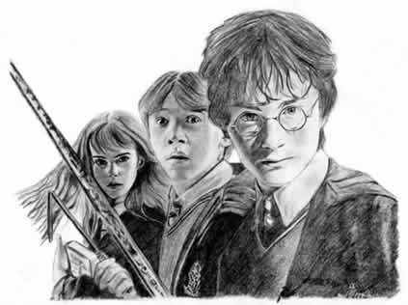 | a. Wizard ______________________  b. Black hair ___________________  c. Freckleless __________________  d. Muggle ______________________ | e. Brown eyes __________________  f. Red hair ____________________  g. Freckles ____________________  h. Blue eyes ____________________

- Determine the genotype for each using the information in the table above.
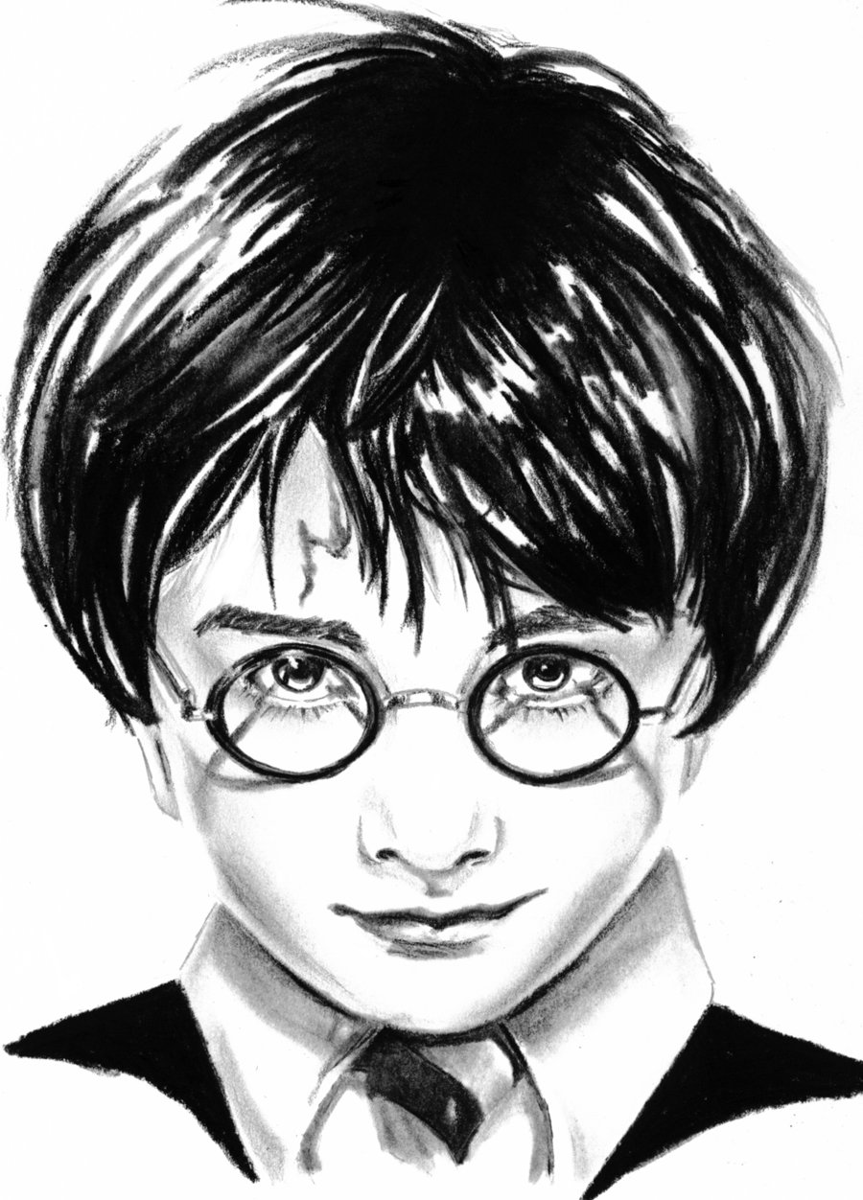
a. Homozygous brown eyes _________  b. Heterozygous muggle _________ | c. Hybrid black hair _________  d. Purebred freckleless _________

- Harry Potter’s parents were murdered when Harry was only a year old. But those that knew Harry’s parents always told him that he had “James’s dark hair and Lily’s green eyes.” Use your understanding of genetics to answer the questions below.

a. Lily was Harry’s mother. She was muggle-born and had the most beautiful red hair. While attending Hogwarts she met and married James Potter. James was heterozygous for his dark black hair. Shortly after they wed, Harry was born. Draw a Punnett square to show the possible genotypes for Harry.

b. Based on Harry’s hair color, what is his genotype? ________
c. Harry always liked a girl named Cho who is heterozygous for her long black hair. What is her genotype? ________

d. Draw a Punnett square to show the possibilities that would result if Harry and Cho had children.
e. List the possible genotypes and phenotypes for their children.

f. What are the chances of a child with black hair? ____ out of ____ or ____%

g. What are the chances of a child with red hair? ____ out of ____ or ____%
- Unfortunately, Harry and Cho do not work out and Harry falls in love with, and marries, a stunning red head named Ginny Weasley. Ginny is the kid sister of Harry’s best friend Ron Weasley. Mr. and Mrs. Weasley are ecstatic that Harry and Ginny are expecting their first child. They already know that there is a 50% chance the child will have red hair but they are also hoping the child will be freckleless, like Harry. If Ginny is homozygous for her freckles, what are the chances the child will be freckleless? Draw a Punnett square and then explain your answer.

Explanation

- Hermione Granger, a friend of Harry’s, is an extraordinary witch and was top of her class at Hogwarts. Hermione is muggle-born which means she is the child of two muggles or non-magical parents. Explain how this is possible. Draw a Punnett square to support your answer.

Explanation

- Mr. and Mrs. Weasley have 7 children and all of the children have red hair like their parents. Mrs. Weasley has brown eyes but Mr. Weasley’s eye color is unknown. Four of their 7 children have blue eyes and three have brown eyes.

a. If Mr. Weasley’s eye color is blue, what must be Mrs. Weasley’s genotype? Explain how you arrive at your answer. Draw a Punnett square to support your answer.

Explanation

b. Is it genetically possible for both Mr. Weasley and Mrs. Weasley to have brown eyes? If so, what are their genotypes? Explain how you arrive at your answer. Draw a Punnett square to support your answer.

Explanation

