Click the following link and follow the screen shots below:

- https://www.servsafe.com/access/ss/Catalog/FreeFoodHandlerProducts
  - This is what you should see

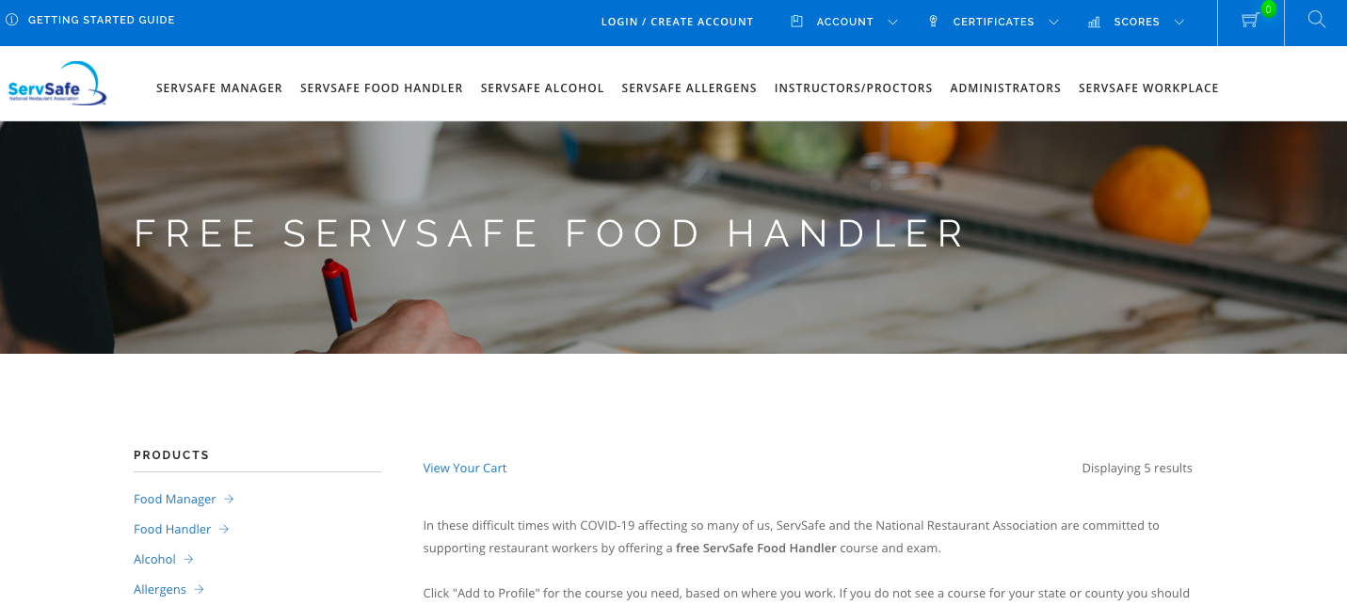

- At top, click on “CREATE NEW PROFILE”

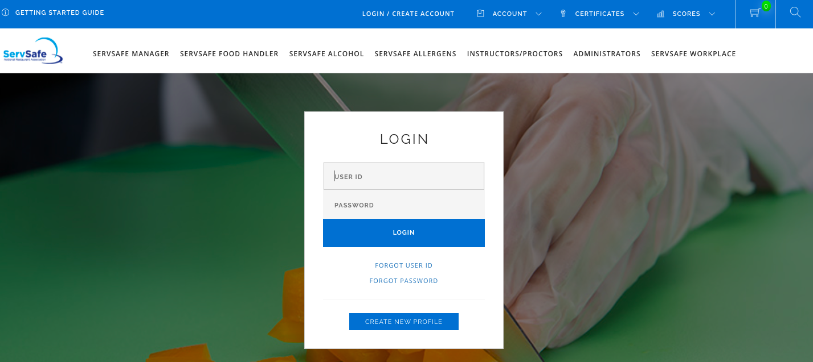

- Begin to fill in information with a RED ASTERISK***** next to it.
  - Remember your login and password.
  - Do not fill in the exam session at the very bottom as we are not checking our score.

  - Check box that says “I’M NOT A ROBOT”
  - Click green ‘REGISTER’ button

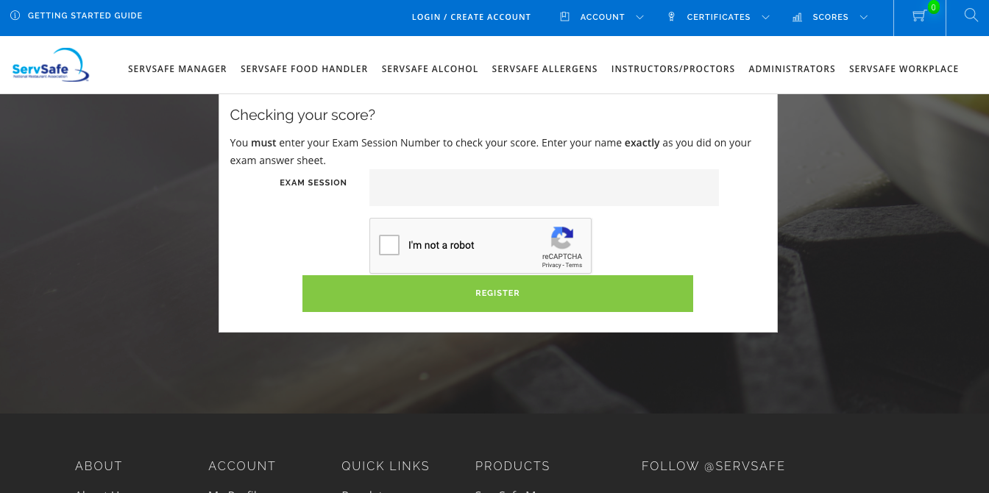

- You are now registered! Go back to the top and click on LOGIN/CREATE ACCOUNT
  - Type in your username and password

- Click on the following link after you login:
  - https://www.servsafe.com/access/SS/Catalog/FreeFoodHandlerProducts
  - This is what you should see (again):
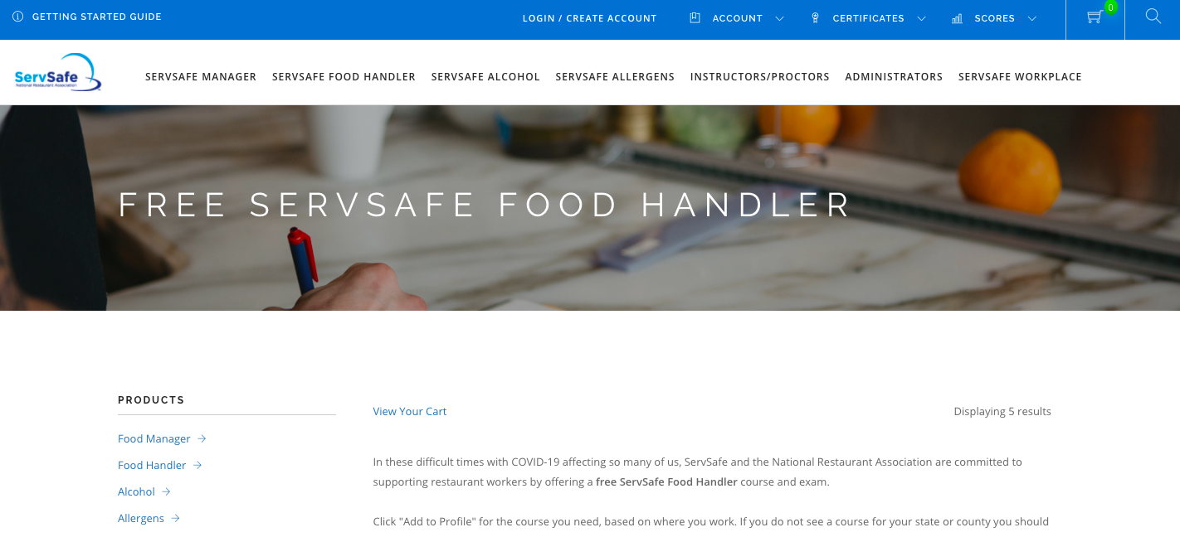

  - Scroll down until you see this first option, click on ADD TO PROFILE

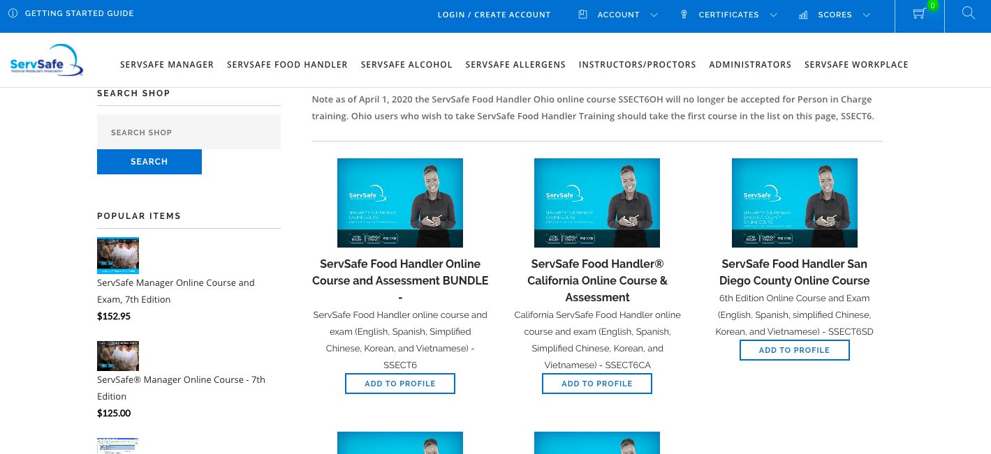

- You should then be taken to MY ONLINE COURSES
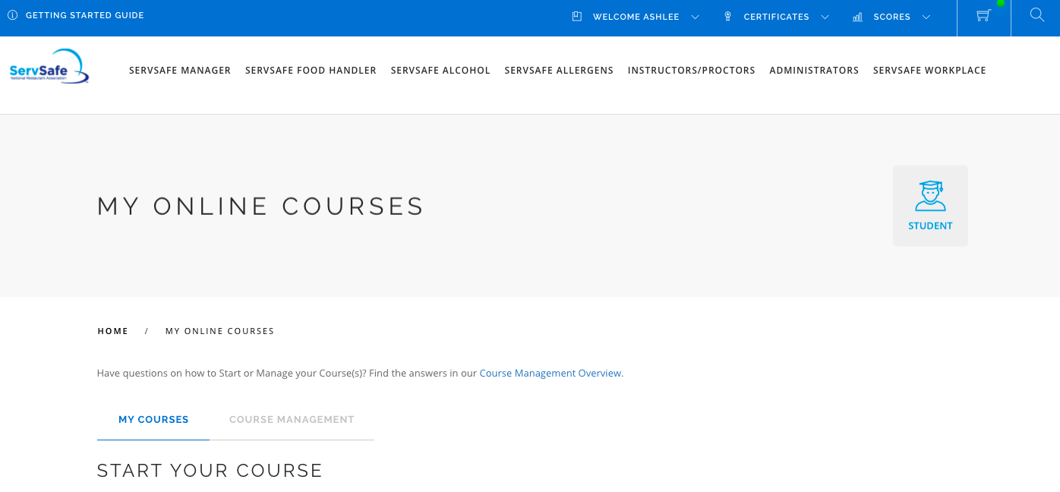

  - Scroll down and you should see the course listed. Click on the LAUNCH button.
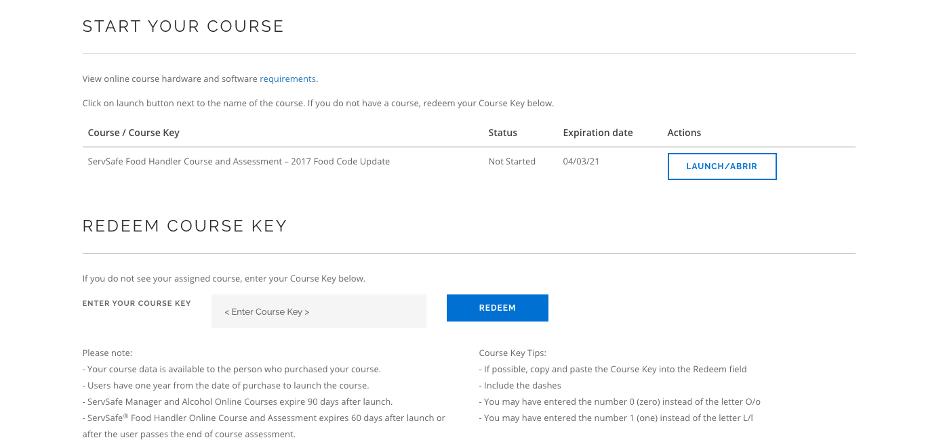

  - There is a version that costs $15. If you ended up clicking on that version, DO NOT TAKE IT. You should NOT have to pay for this course/certification. Email me and we will figure out how to get you to the FREE version.

