Chapter 8 Note Guide The Safe Flow of Food
1.Cross Contamination happens when _______________ spread from one __________
to ____________.
- You need to know how to _____________.
- Separate ________ food from _______-____-______ food.
- __________ and ___________
- ________ food at different ____________
- Store __________ separately

2. Time-Temperature Abuse
- ________ in temperature _______ zone too long.
- _________ grow well between _____ to _____F or _____ to ____ centigrade.
- Pathogens grow ________ between ____ to _____ F or _____ to _____ centigrade.
- _________ than ______ hours throw _____ food
- ________ time in ___________ zone.
- ________ to _________ temperature
- _______ at __________ temperature
- ____________ or ____________ improperly

4. Thermometers are used to ___________ temperature.
- A ________________ stemmed thermometer is used for temperature between
______ to _______ F or ______ to ______ centigrade for hot and ______ foods.

5. How to use a thermometer. Fill in blanks below.
- Insert ______ to _________
- Sensing area is ______ to _________
- Used for __________ or ____________ food
- Insert in ___________ part of food
- Insert usually in _______ of food
- Take ______ readings
- __________________ may vary
- Wait for ___________ to __________
- Allow _____ seconds
- _______________ adjusted __________ for _____________

6. Thermometers need to be calibrated. Fill in blanks.
- Thermometers ______ accuracy from being _________ or ___________.
- Follow manufacturer’s ______________
- There are two ways to calibrate. Name 2 ways
A._____-Point method water _______ B. __________-Point method water ________

7. Explain the Ice Point method of calibration.
- Fill ____________ with __________
- Add tap __________ until _________
- Stir __________ well
- Put thermometer __________ in _______ water
- ___________ area ____________
- Wait ______ seconds
- Don’t let ________ touch ______________
- Adjust thermometer to _______ F or _______ Centigrade
- Use _________ or other tool
- ________ nut until __________ F

8. When cleaning thermometers, ___________ and keep storage cases __________.

9. When purchasing thermometers, use approved ____________ suppliers.

10. Train staff to do 3 things, ________________,___________ and ______________.
- ____________ carefully and _________________
- _______ away quickly.
- ___________ in _____________ order
- ___________ or ____________ guidelines

11. To take a temperature you _______ the thermometer in the ___________ part.
- Insert thermometer between_______ packages.
- ___________ around thermometer
- Do not _____________ package.
- Open the ___________ and insert ___________ into the food.
- Sensing area ________________
- Do not _______ package with the ___________.

12. The receiving temperatures
- Cold TCS Food _____ F or _____ C or lower
- Hot TCS Food ______ F or ______C or higher
- Frozen ______ is frozen ____________
- Reject food with _______ crystals on the ___________ and ____________
- Reject _________ and ______________
- Reject food with ______________ or frozen ___________ on ________ of case.
13. Packaging should be _________ and _________

14. Reject products that are the following:
- ____________,_____________ or _______________ cans
- Packaging with _________, holes,__________,leaks,________________,water
______________
c. _____________ damage
d. ____________ use-by ___________

15. Packaging must contain the following:
- __________________ stamp
- Meat, ____________ ,______
- Meet ___________ standards
- State department of _____________
- USDA stands for ___________ __________ _____________ of _____________

16. You should always reject food if the following are present:
- ___________ or ____________ color
- __________, sticky or __________ texture
- Soft ___________
- _____________ or __________________ odor
17. There are specific receiving guidelines for each food. Fill in blanks.
A Shellfish which includes _____________,______________,clams and ____________
- Air temperature of _______ F or _________ centigrade
- Internal temperature less than ______ F or ______ centigrade
- Cool to _________F or _________ centigrade or lower in _________ hours
B. Shucked shellfish include ____________,___________, clams and __________
- Removed from _______
- _________ F or __________ C or lower
- Cool to ________ F or ______ C or lower in _______ hours

18. Shellfish have identification cards. Fill in blank.
- Live ___________
- ____________ to delivery ______________
- Write _________last _____________ sold or ______________
- Keep tags for __________ days

19. Reject shellfish if:
- Very __________ b. Broken _________ c. ___________

20. Eggs should be :
- Clean and ______________ b.______ F or _______ C or lower
c. __________ grade standard

21. Liquid, frozen and ____________________ eggs should be _________________ with
An ________________ inspection ___________
22. Milk and dairy products
- Should be kept at _________ F or ________ C or lower
- Should be kept at _________ F or _________ C or lower in ________ hours
- ________________
- FDA Grade ______ Standards

23. TCS Food
- ______ F or _____ C or lower
- ______ F or ______ C or higher
- __________ temperatures

24. Storage of TCS foods should be labeled when ___________ in house and held over _______ hours. The label should include name of _______ and date to be _______, eaten
or __________ out. After _______ days food should be thrown _______, Store for
_______ days or less at ______ F or _______ C or lower.

25. Storage you need to __________ inventory using ___________ first.
Use the FIFO method or ________ in and ________ out.
- Identify _____-by or ___________ date.
- ___________ earlier items _________
- Use items _________ in ____________ first.
26. Preventing cross contamination during storage is important. Fill in blanks.
- _________ or cover ___________
- Separate ________ from ______-to_____ food
- Prevent ________ dripping onto _______-to_____ food.

27. Top-to-bottom order in storage is as follows:
- ____________-to_____ food
- ____________
- Whole _______ of ________ and ______
- Ground ______ and ground __________
- Whole and _________ poultry

28. Do not overload ___________ or freezers since it _________ good ___________ and
harder to stay _________.

29. Do not ___________ cooler or freezer ___________ since it blocks ______________.

30. Preparation should be aware of following. Fill in blanks.
- ________ ________________ abuse
- _________ only as much as __________
- ____________ in small ____________
- __________________ not in temperature ___________ zone.

31. When thawing, ___________ does not kill _______________. Never __________ at
room ____________________.

32. Thaw TCS food in a _____________ at _____ F or _____ C or lower
- Thaw food ________________ under ________________ water or _____ F or _____ C
- ____________ water
- Never leave food above _______ F or _____ C for over _______ hours.
- Can thaw food in the ____________
- Can thaw as part of the _______________ process

33. Cooking is ______________ for safe food.
- ____________ temperatures
- ___________ amount of __________
- ______-risk _______________
- No _______ seed _______, raw or ________________ eggs, _______ or ________

34. Cooking requirements for Poultry. Fill in the blanks.
- _______ F or ________ C for ______ seconds for poultry, including ________ or _________ or duck
- ______________ made with TCS ingredients
- ___________ meat,____________, poultry or ___________
- ____________ that include ______________ cooked TCS ingredients

35. Cooking requirements for Beef. Fill in the blanks.
- _______ F or ______ C for ______ seconds
- Ground _______ including ________, _________ or other meat
- ____________ meat including brined ________ and flavor __________ roasts
- ____________ tenderized _________
- Ground ___________ including ___________ or ______________ seafood
- ________ eggs that will be _______ held for ___________

36. Cooking requirements for Seafood and meat. Fill in the blanks.
- Seafood including __________,____________, and ______________________
- Steaks/_________ of ________, __________,__________ or ____________
- Shell ________ that will be served ___________________
- ___________ F or ___________ C for ____________ minutes for roasts of
_____________,______________,_____________ and ____________

37. Cooking requirement for commercially processed ready-to-eat food that will be held for
service should be _______ F or ___________ C

38. Fruit,_______________, _____________,and ____________ that will be _______
held for service should be at _______ F or ______ C
39. When holding food should be kept at following temperatures:
- Hot food at _______ F or ________ C or higher
- Cold food at _______ F or ________ C or lower
- Check ________________ every _______ hours
- Do not __________ in _____-holding ______________

40. Cooling should be in following ranges:
- _____ F or______ C to ______ F or _______ C within 2 hours
- _____ F or ______ C to ______ F or ______ C in the next ______ hours
- _____ F or _______ C within _____ hours or ________ out or ___________
and _________ again

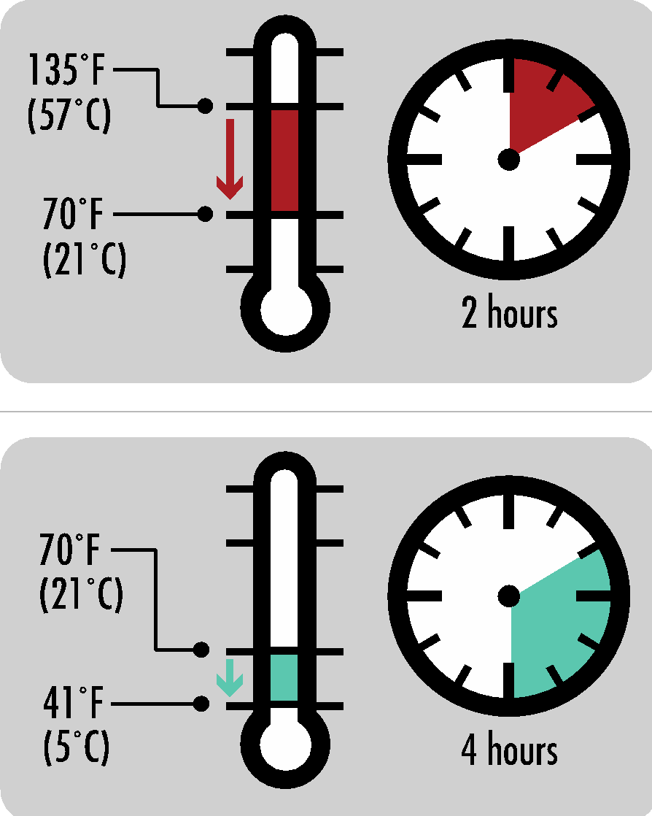

41. To help cooling you can also do the following:
- Reduce ________
- Cut __________ items into __________ pieces
- Use __________ or ____________ containers
- ________- water bath
- Ice ___________
- Add _______ as ____________
- Blast _____________

42. Reheating foods you should do the following.
- _______________ service you should ___________ to any ______________
- _____________ and ______________ correctly
- Hot-Holding you should __________ TCS food to _______ F or ______ C for
_______ seconds within ______ hours

43. When serving ready-to-eat foods you should do the following:
- Use ________, _______ sheets or __________
- Separate __________ for each __________
- ___________ and sanitize
- Extend __________ above the __________
- Place on ___________ and _________________ surface

44. Guidelines for service staff include:
- Do not _________ food-__________ areas of __________ or ____________.
- Hold dishes by _____________ or ____________.
- Do not ___________ glasses when ________________ them
- Carry ____________ in a _____________ or _______
- Do not hold ____________ by _______- contact surfaces.
- Hold ____________ by the ____________
- Store so ___________ grab by the ______________.
- Avoid ___________-hand ____________ with __________-to______ food
- Handle ready-to-_______ food with ________, deli ________ or ___________
- Never __________ ice with __________ hands or _______________
- Use _______ scoops or _____________
45. Off -site food delivery includes:
- ________________
- Mobile/ ___________ ______________
- ________ machines
- Use ___________ containers
- Check _________ temperatures
- Clean _____________ vehicles
- Label food by _____-by-date and _________
- Correct _____________
- Store ____________ correctly

46. Food Safety Management System is a ___________ of ____________ and ___________.
- __________ together to __________ foodborne ____________
- Controls ___________ and _____________

47. Active managerial control includes following:
- Control __________
- _____________
- ___________ risks

48. You achieve active managerial control through the following:
- ______________ programs
- Manager ________________
- SOP or _______________ _________________ _________________
- _____________

49. HACCP stands for ___________ __________ ____________ _____________ _________
- The HACCP _____________ major ____________
- ____________, eliminate or ____________

50. HACCP has a written plan on operations for the following:
- __________
- _____________
- _____________
- ______________
- _____________
- Each _____________ is _______________
- _____________
- _______________ action
- ____________

