Foodborne Illness Wanted Poster
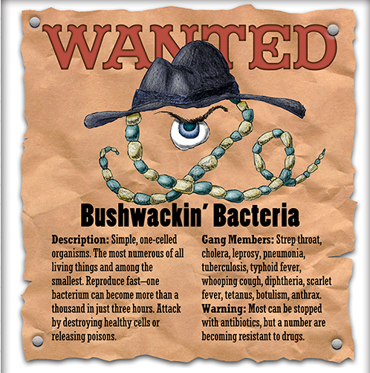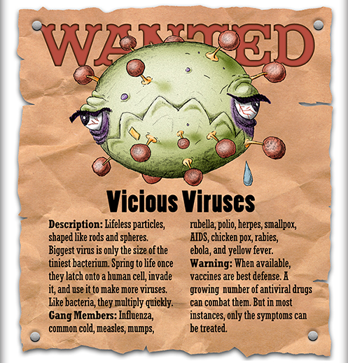
Create a poster for an assigned foodborne illness. Circle your assigned Foodborne Illness below.

Foodborne Illness:
Campylobacter Clostridium Botulinum Clostridium Perfingens
E-Coli Listeria Salmonella
Staphylococcus

_________ 5 Points: Name – Give your foodborne illness an interesting criminal name
_________ 5 Points: Description – Give a description of the foodborne illness. Describe what it is, conditions it thrives in, and other information that you find important to know about it
_________ 2 Points: Location – Where can it be found hanging out
_________ 2 Points: Gang Members – symptoms that it causes
_________ 2 Points: Warning – How to prevent this type of foodborne illness from occurring
_________ 1 Points: Picture of foodborne illness
_________ 5 Points: It is clear that the student put effort into the assignment, completed it neatly, and used class work time appropriately

________ out of 22 Points

