Knife Quiz Name________________________________
20 Points/Culinary Arts 1

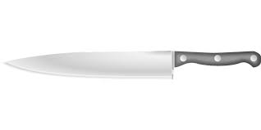
Label the part of the knife to include the following: 5 points
TIP, BOLSTER, SPINE, BLADE, TANG

Identify each knife and explain its primary function (10 points):
Knife Graphic | Knife Name (1 pt) | Function (1 pt)
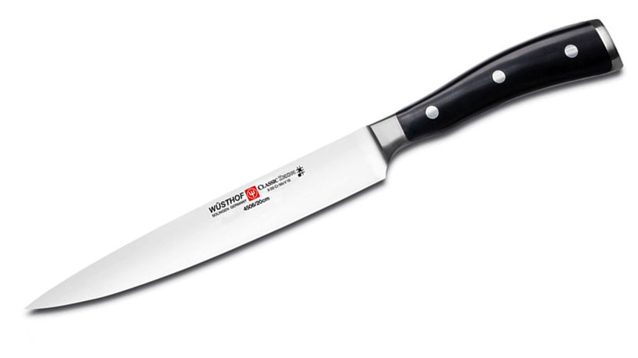
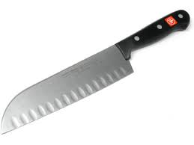
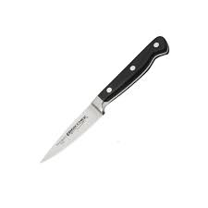
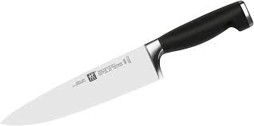
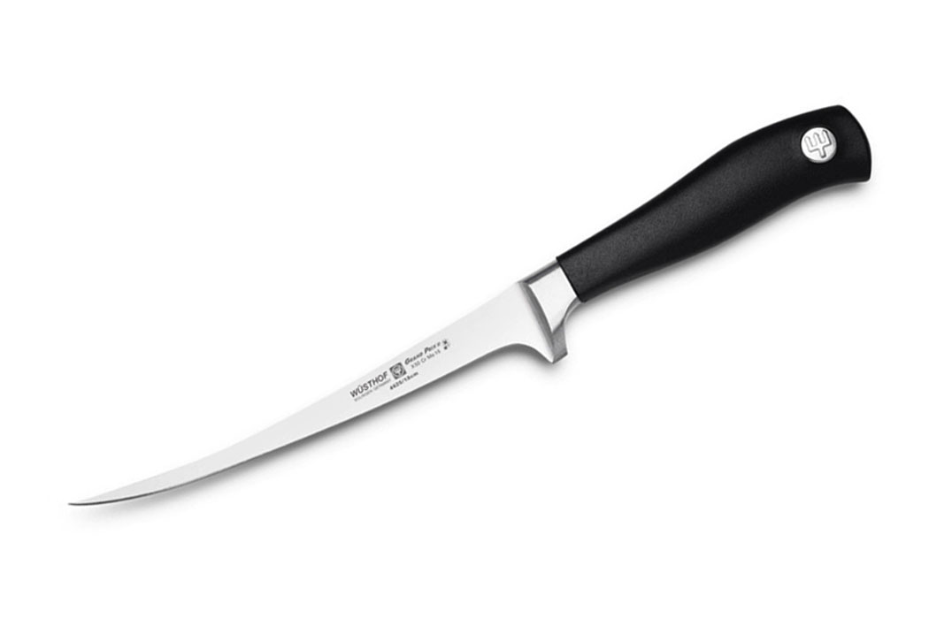

Identify the size of each knife cut (5 points):

Julienne:

Brunoise:

Medium Dice:

Chop:

Battonet:

