CHAPTER 12 KNIVES AND SMALLWARES NOTE GUIDE

Matching
- Bench scraper ______removes scales from fish
- Bowl scraper ______ scissor-like utensil to pick up and handle solid food
- Channel Knife ______ pipe out frosting, creams or pureed food
- Peeler ______ weigh dry ingredients
- Grater ______ round-tipped tool to level dry ingredients or ice cakes
- Zester ______ precise scale, measure weight, US and metric
- Bakers rolling pin ______ remove foam from stock or soup, flat head with holes
- Classic rolling pin ______scrape material off of work space, metal blade
- French rolling pin ______ measure recipe ingredients ¼ ounce to 2 pounds
- Pizza cutter ______ scraper to fold ingredients together, scrape sides of bowl
- Fish Scaler ______ used to puree food and several grating screens
- Corer ______ wedge spatula to life out and serve pie pieces
- Parisienne Scoop ______ shaped like a drum and remove solids from puree
- Can opener ______ cuts a thick layer from fruit and vegetables
- Kitchen shears ______ solid, perforated or slotted stainless steel
- Pastry Bag ______ kitchen fork to lift items onto plate
- Pastry Brush ______ pieces of cooked food pressed thru sheet of small holes
- Piping Tools ______ cuts lengthwise grooves
- China Cap ______whisk to mix, beat and stir food
- Colander ______shreds small pieces of outer peel of citrus fruits
- Strainer ______pastry wheel and cuts rolled out dough
- Sandwich spreader ______ends are tapered to flatten or shape dough
- Offset spatula ______cut butcher’s twine or string and grapes into clusters
- Straight spatula ______flexible piece of rubber or plastic, cut and separate dough
- Food Mill ______remove core of apples or pears
- Ricer ______straight cylinder to roll over pastry
- Tamis/drum sieve ______mounted onto utility table to open large cans
- Cheesecloth ______melon baller and cuts round shapes from soft fruits
- Funnel ______stands on metal feet and drains liquid while retaining solids
- Sieve ______shredder to grate food into fine pieces
- Wire whip ______strains pasta or vegetables and shaped like a bowl
- Skimmer ______brush egg wash, melted butter, glazes onto baked goods
- Rubber spatula ______light mesh gauze to strain liquid or bundle herbs
- Cook’s Fork ______decorative tips, piping bags and presses
- Tongs ______long, narrow tool to frost cakes or spread layer of batter
- Spoons ______cone-shaped strainer for soups or stock or other liquids
- Pie Server ______sifter to combine and aerate food product
- Portion Scale ______two handles attached to a center dowel to shape dough
- Digital electric Scale ______short, stubby spatula to spread condiments
- Baker’s Scale ______ pour liquids from a larger container to a smaller one
Matching
1. Bimetallic stemmed thermometer ______ similar to liquid measuring cups but bigger
2. Thermocouple _____large pot for preparing stock, some have spigots
3. Ladle ______ lower pot holds boiling water,upper pot melting
4. Portion Scoop ______ small, round cups or molds
5. Measuring Cups ______straight sides, variety of sizes and shapes
6. Measuring Spoons _____ heavy thick pan to pan fry vegetables or meat
7. Volume Measures ______ very shallow pan one inch deep
8. Brazier ______holds prepared food, steam table, baking
9. Double Boiler ______portion out liquids, measure fluid ounces
10. Saucepot ______long narrow metal pan, perforated rack
11. Stockpot ______ slope sided thin metal for quick heating
12. Cake Pan ______ wide bottom, poaching, pan frying, stir frying
13. Springform Pan ______ check temp of large food for 15 seconds
14. Muffin Tin ______ shallow skillet, create crepes
15. Hotel Pan ______ rondeau, braise meat and vegetables
16. Roasting Pan ______scoop out soft foods,short handle measuring
17. Sheet Pan ______ medium height, straight sides,general cooking
18. Cast Iron skillet ______ shallow rectangular pan,medium high sides
19. Saute Pan ______ check temperature of thick or thin food
20. Sauce Pan ______ two-part spring-loaded baking pan
21. Sautoir ______ measuring dry goods and liquids
22. Wok ______ Asian cooking, easy to toss or stir food
23. Fish Poacher ______ more shallow than stock pot to prepare soup
24. Crepe Pan ______ measure small quantities of spices or liquids

Care of Pots and Pans
1. Aluminum you should _______ wash in _________ water with ___________ cleaner.

2. Chrome pots you should wash in _________ water with ______ and __________ cleaner.

3. Copper pans you should use a ______________ cleaner to remove _____________ before
washing.

4.Cast iron pots should be washed in _________ water with ___________ detergent and
_________ dry. Re-apply thin layer of _____.

5. Stainless steel pots should be washed in hot _________ water and ________ thoroughly
and _____ dry.

6. Nonstick coating pans you should use a plastic ________ scrubber to avoid ____________.
You should ________ all _________ from bottom of pan so _______ not _______.

7. Knives are the most widely used kitchen equipment. Fill in blanks for parts of a knife.
- A knife has two main parts, a ____________ and ___________.
- A forged blade has a _________ piece of heated __________.
- ____________ on a _________
- __________ with a ______________
- __________________ into correct __________.

8. A stamped blade has a ____________ blade from ___________ of milled __________.

9. Parts of a knife. Explain each part.
- The tip is used for __________ work and __________,__________ and _________.
- The cutting edge is the ____________ of the _________, between ______ and _____.
- The edges are flat _________ and _____________.
- The edges are _________________,_________ ___________, _____________, _________ ___________.
- The spine is the _____ of the blade and a _____________________ edge.
- The heel is the _________ and ___________ part of the blade. It can cut through the
__________, __________ or ________ ___________.
g. The bolster is the ________ of the blade and where the blade meets the ___________.
h. The tang is the metal from ___________ through ___________.
i. Full tang means as long as the ____________ handle and includes _______ _______ and
_____________.
j. Partial tang is for _________ work and includes _________ or ________ ___________.
k. The scales make up the ___________.
l.The rivets hold ___________ to _________.
m.The butt is the end of the ____________.

10. Honing is regular _____________ to keep knives __________.
11. Steel is a long ________ rod that is lightly __________ and ______________.
Steel removes_______________ _______ which dull the __________.
Knife returns to __________ shape and use steel ____________.

Be able to label the parts of the knife.
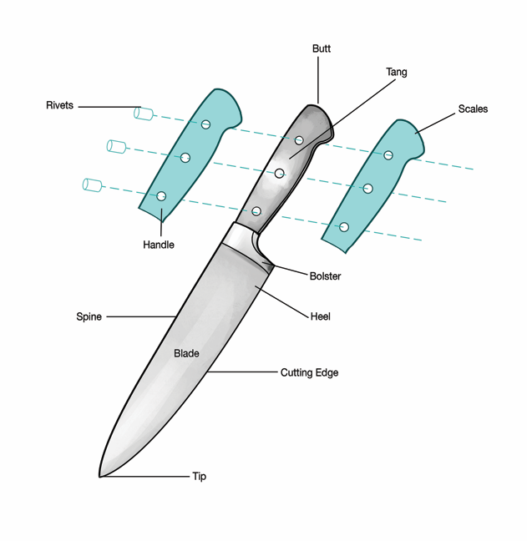

Matching
- Chef’s (French) Knife _______slice cooked meat, blade can be 14 inches
- Cleaver _______trim and pare fruits vegetables, small knife
- Santoku _______curved knife to cut beef steaks from loin
- Boning Knife _______short sword, remove broken pieces
- Slicer _______short, blunt point to shuck clams
- Serrated Knife _______All Purpose Knife,chopping, slicing, mincing
- Paring Knife _______short, stubby knife to shuck oysters
- Tourne _______separate raw meat from bone,thin, flexible blade
- Steak Knife _______slender, metal rod, sometimes flattened
- Clam Knife _______heavy, rectangular knife,cut through bone
- Oyster Knife _______slender ceramic rod, ceramic and metal knives
- Ceramic Steel _______Granton indented notches, release food easily
- Diamond Steel _______Bird’s beak, cut curved surfaces of vegetables
- Honing Steel _______long, thin serrated blade to slice breads and cakes

15. Knife care includes a sharpening stone. Fill in blanks.
- ___________ and _________ edges
- Remove __________ from ___________
- Use only when _________ does not _________.
- Knife held at _____ degree _______.
- Blade passes over _________ or ___________ stone.
- _________ number of ________ on each _______.

16. Proper care and use guidelines for knife use. Fill in the blanks.
- Keep ___________ sharpened.
- Use only for ________ purposes.
- Keep _______ clean and ______
- Do not _______ knives in ___________.
- Never ________ or _________ with a knife.
- Do not _________ others using __________.
- Do not _________ a falling _________.
- Store in knife _________, ___________, or ___________.
- Do not ___________ someone __________ a __________.

17. Knife Basics include the following. Fill in blanks.
- Use _______ hand to ________ food.
- Other ___________ holds knife ____________.
- Two basic knife ________ are ___________ _________ and _________ _________.

18. The guiding hand is hand _________holding the ___________.
- The guiding hand __________ slippage
- The guiding hand ____________ the ________ of the cut.
19. The claw grip is the most ________________.
- The claw grip ________fingers _______ toward _______.
- Make sure to hold ___________ well back.
- There are _____ classical ________ cuts.
- __________ time
- Use proper __________-skill ______________
- Cutting ___________ should be ___________ and _____________
- Knife blade should be _____________ to cutting ___________.

20. Matching
- Large Dice ______1/4 inch thick slices
- Medium Dice ______1/2 inch by ½ inch by ⅛ inch
- Small Dice ______1/2 inch by ½ inch by ½ inch
- Brunoise ______football shaped, 7 equal sides,¾ inch diameter
- Batonnet ______3/4 inch by ¾ inch by ¾ inches
- Julienne ______1/4 inch by ¼ inch by ¼ inch
- Rondelle ______leafy vegetable stacked, 2 inches rolled tight, ⅛ inch wide
- Diagonal ______1/8 inch by ⅛ inch by ⅛ inch
- Paysanne ______1/4 inch by ¼ inch by 2 inches
- Chiffonade ______1/8 inch by ⅛ inch by 2 inches
- Tourne ______1/4 inch thick oval slices

