Weebly WebSite Tutorial for culinary e-portfolio

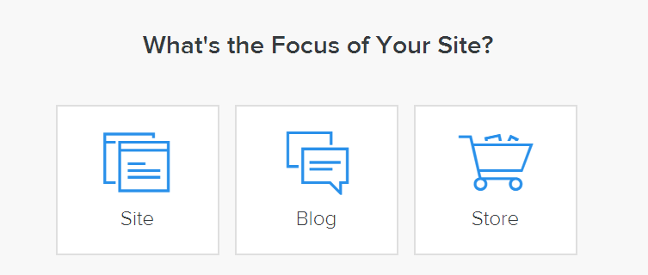

Go to www.weebly.com and create a username (recommended: Your Name) and password.

Click on Site

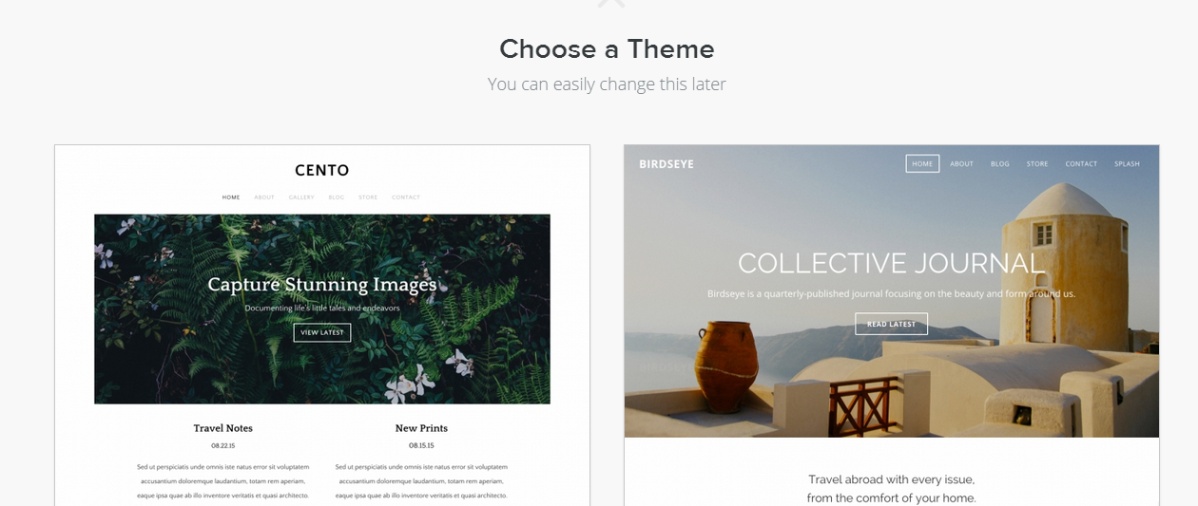
Choose a Theme

Choose a SubDomain as Your Name
- Watch the Introduction Video to Weebly
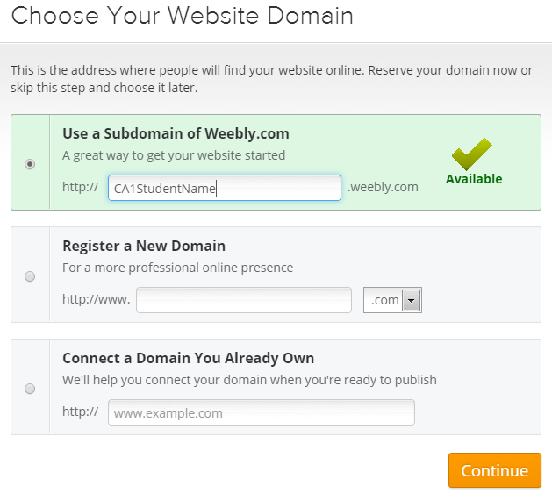

- Click on Pages to begin creating the pages required for your portfolio:
- Home (Includes your name and class(es) enrolled)
- 1 Blog Page per Class
  - If you are enrolled in both Culinary Arts 1 and 2, you will have two blog pages on your one website.
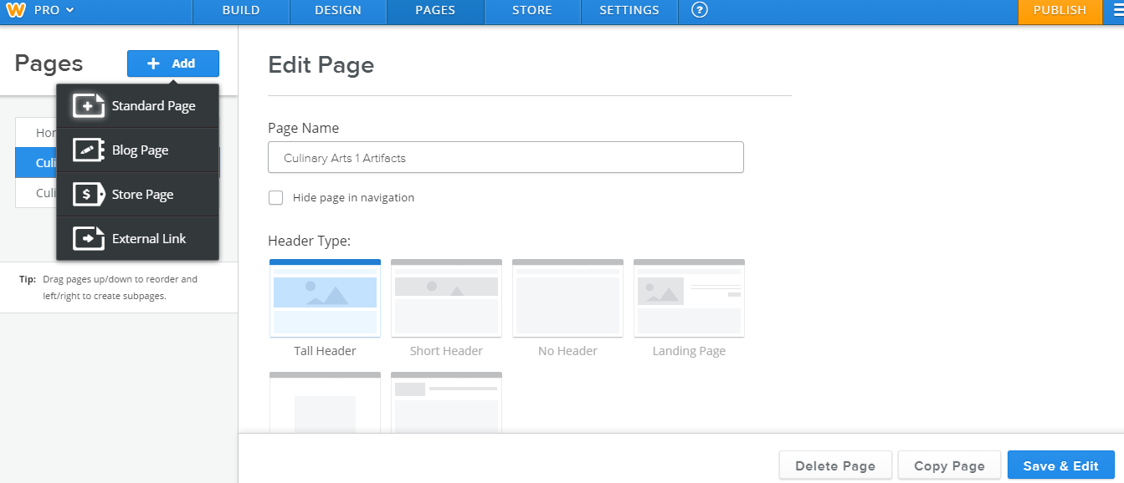

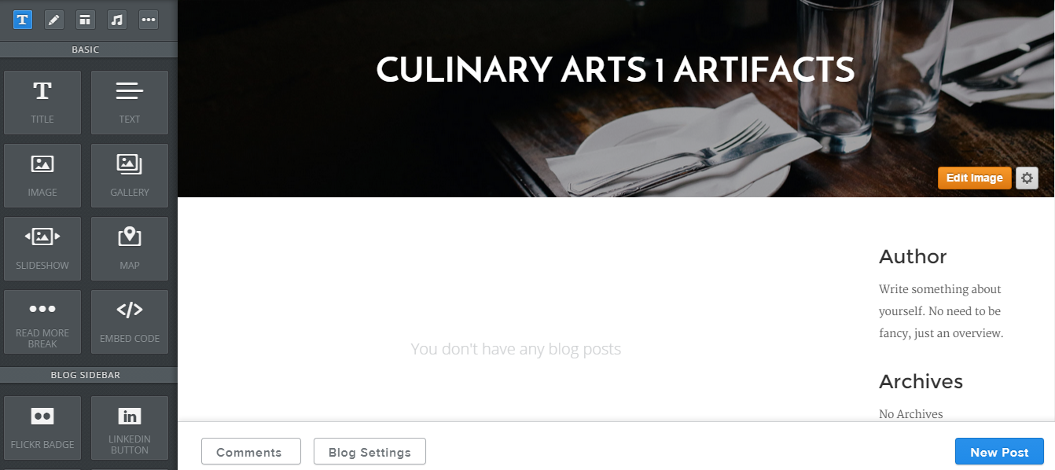
- Within your blog’s page, enter each artifact entry. Be sure to include all required documents (see rubric). For each new post:
- Click on Create New Post in the lower right hand corner.
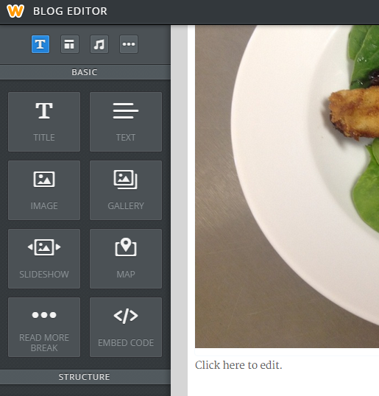
- Type the name of the recipe in the Subject Line
- Drag an Image box AND a Text box under the Recipe Name.
- In the Text box, copy/paste the following and answer each in as much detail as needed:
  - Picture of prepared recipes (2 pt)
  - Date prepared (1 pt)
  - Name of recipe linked to source used (2 pt)
  - Describe the cooking techniques used in this lab (i.e. baking, broiling, sauteing, etc) (1 pt)
  - Identify the knife cuts and food item(s) using the knife cuts this lab *Type NA, if needed (1 pt)
  - What new skill(s) did you learn through this lab? *complete sentences (2 pt)
  - What could you improve upon the next time you make this? *complete sentences (2 pt)
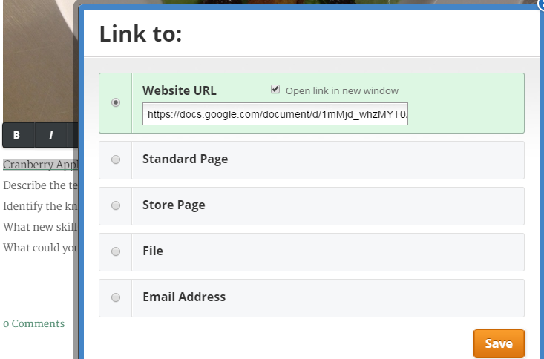
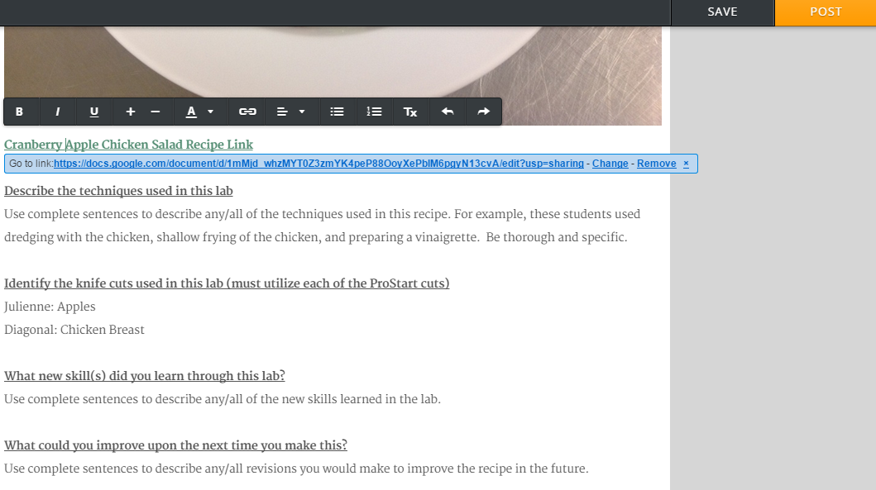
- Link the recipe name under the picture to the recipe link by highlighting the name and clicking on the icon. Enter the URL (be sure to make any Google Doc recipe template is PUBLIC to view)
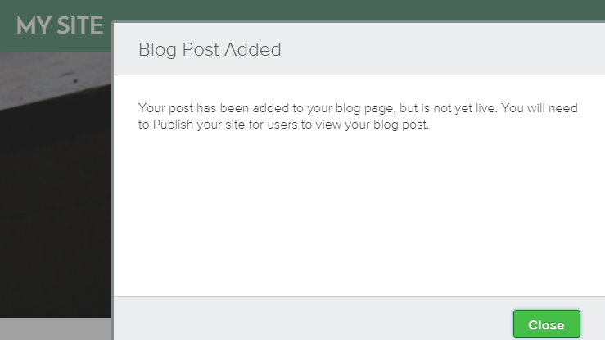
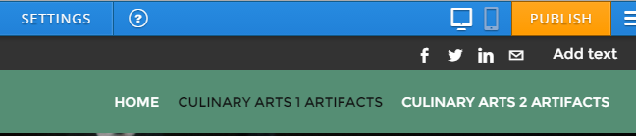
- Click SAVE after each entry and PUBLISH when ready for viewing.

