Monarch Culinary Arts: 1st Annual Coolest Cookie Contest
The first annual Monarch Cookie contest is here!
You will be designing your own signature cookie and competing against your classmates for the best new cookie.
The rules of the contest are as follows:
- Your cookie cannot be an existing recipe that you have ever made or heard of. I realize there are only so many possibilities out there and if your cookie happens to be very similar to a cookie that exists, then I will give you the benefit of the doubt that you have not heard of that cookie before and it’s just coincidence that they’re similar.

- Your cookie must not exceed a certain portion cost : $.20 per cookie. You will figure out your cookie’s cost by doing the recipe costing form that we used in Chapter 14.

- You must create an accompanying “advertisement” for your cookie as you will be attempting to pre-sell it to as many teachers/school staff as possible (I suggest you use google draw). You will need to seek out staff/teachers on your own to advertise your cookies, I will print out your advertisement for you if you want me to so you can distribute it!
- You must identify somewhere on your advertisement what type of cookie it is (bar, drop, molded, etc).

- Your recipe must make 24 cookies (2 dozen). You may elect to use the base cookie dough recipe I will provide, or you can come up with your own recipe based on what we’ve learned in class about baking.

- You must work on this BY YOURSELF. You may ask Ms. Jarvis, your parents, etc for suggestions but may not work with another classmate.

- Good luck! May the best cookie win!

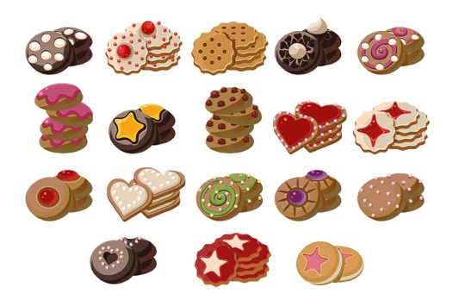

Cookie Base Recipe:

Ingredients:
- 2 cups flour
- 1 Tbsp cornstarch
- 1 tsp baking soda
- 3/4 tsp kosher salt
- 3/4 cup butter, room temperature
- 3/4 cup dark brown sugar
- 1/2 cup granulated sugar
- 1 egg
- 1 Tbsp vanilla
- 1 1/2 cups your favorite candy or chocolate chips
Instructions:
- Preheat oven to 350°F. Line baking sheet(s) with parchment paper, set aside
- In medium bowl whisk together flour, cornstarch (if adding) baking soda and salt. Set aside.
- In mixer cream butter and both sugars together on medium speed, beating until light and fluffy 2-3 minutes. Turn mixer to low and add in egg and vanilla. Turn mixer back up to medium and mix until incorporated, scraping sides when necessary.
- Turn mixer to low and add in flour mixture until dough comes together.
- Stir in candy until evenly distributed.
- Drop by heaping tablespoon onto lined baking sheet and bake for 8-9 minutes until edges are just golden. Make sure not to over bake.
- Remove from oven, let cool on baking sheet for 3 minutes, and then transfer to wire rack to finish cooling.

