Gingerbread Dough
You may make up to
3
Batches Each
Of DOUGH AND
ICING

ANY ADDITIONAL BATCHES MUST HAVE INGREDIENTS BROUGHT IN

Ingredients
- 1/2 cup butter, softened
- 1/2 cup shortening
- 1 cup sugar
- 1-1/2 teaspoons ground ginger
- 1-1/2 teaspoons ground allspice
- 1 teaspoon baking soda`
- 1/2 teaspoon salt
- 1 egg
- 1/2 cup molasses
- 2 tablespoons lemon juice
- 3 cups all-purpose flour
- 1 cup whole wheat flour
Directions
In a Kitchen-Aid or large mixing bowl, beat the butter and shortening for gingerbread dough with an electric mixer on medium to high speed for 30 seconds. Add the sugar, ginger, allspice, baking soda, and salt. Beat until combined, scraping sides of bowl occasionally. Add the egg, molasses, and lemon juice and beat until combined. Beat in as much of the all-purpose flour as you can with the mixer. Using a wooden spoon, stir in any remaining all-purpose flour and the whole wheat flour.
Divide dough in half. Cover and chill about 3 hours or until dough is easy to handle.
If desired, cover both sides of pattern pieces with clear adhesive plastic to protect them. Using a floured rolling pin, roll out some of the cookie dough to 1/4-inch thickness on the back of an ungreased 15 x 10 x 1-inch baking pan. Place pattern pieces 1 inch apart on dough. Cut around patterns with a sharp knife. Remove excess dough (save for rerolling), leaving cutouts on pan.
Bake in a 375 degree F oven for 10 to 12 minutes or until edges are lightly browned. Leaving warm, baked cookie on pan, replace patterns and trim away excess dough. (The more precise the pieces are cut, the easier the house will fit together.) Let cookies cool completely on pan or on silicone mat; then transfer to wire racks.
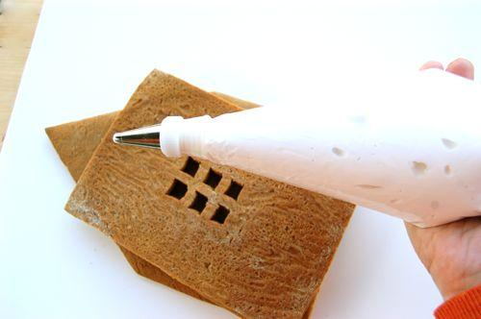
Royal icing
Ingredients
- 2 egg whites
- ½ t cream of tartar
- 2 c powdered sugar

Directions
- Using the Kitchen-Aid, beat egg whites until foamy. Add cream of tartar and continue beating until stiff peaks are formed.
- Gradually add 1 c powdered sugar. Beat for 10 minutes.
- Add the final 1 c powdered sugar. Beat for another 10 minutes.

** If adding food coloring, add during the last 2-3 minutes of mixing.
Helpful hints:
Try not to prepare vast amounts of frosting ahead of time as it will harden and become difficult to use.
Use icing to seal your base and main structure pieces to a foil-covered base
Use icing as the glue to hold pieces together. You may need to stabilize objects with other equipment while drying
Pipe icing using pastry bags, especially in corners and hard to reach places

