Cutting Like a Pro Name________________________________
25 points/Culinary Arts 1

Part 1: Label the part of the knife to include the following: 4 pt
TIP, BOLSTER, SPINE, CUTTING EDGE,
HANDLE, BUTT, HEEL, BLADE, TANG

Part 2: Read pages 274-279 to review the types of knives and knife care.
- Name and describe 2 different types of steels to hone knives. 1 pt

- Name 3 guidelines to properly care of knives (many more are listed). 1.5 pt

- What knife/knives do you find to be most important to have in the kitchen? Explain your answer. 1.5 pt

Identify each knife and explain its primary function: 8 pt
Knife Graphic | Knife Name (1 pt) | Function (1 pt)
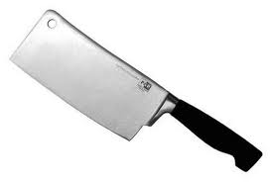
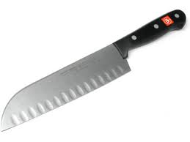
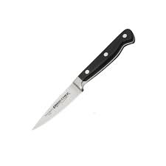
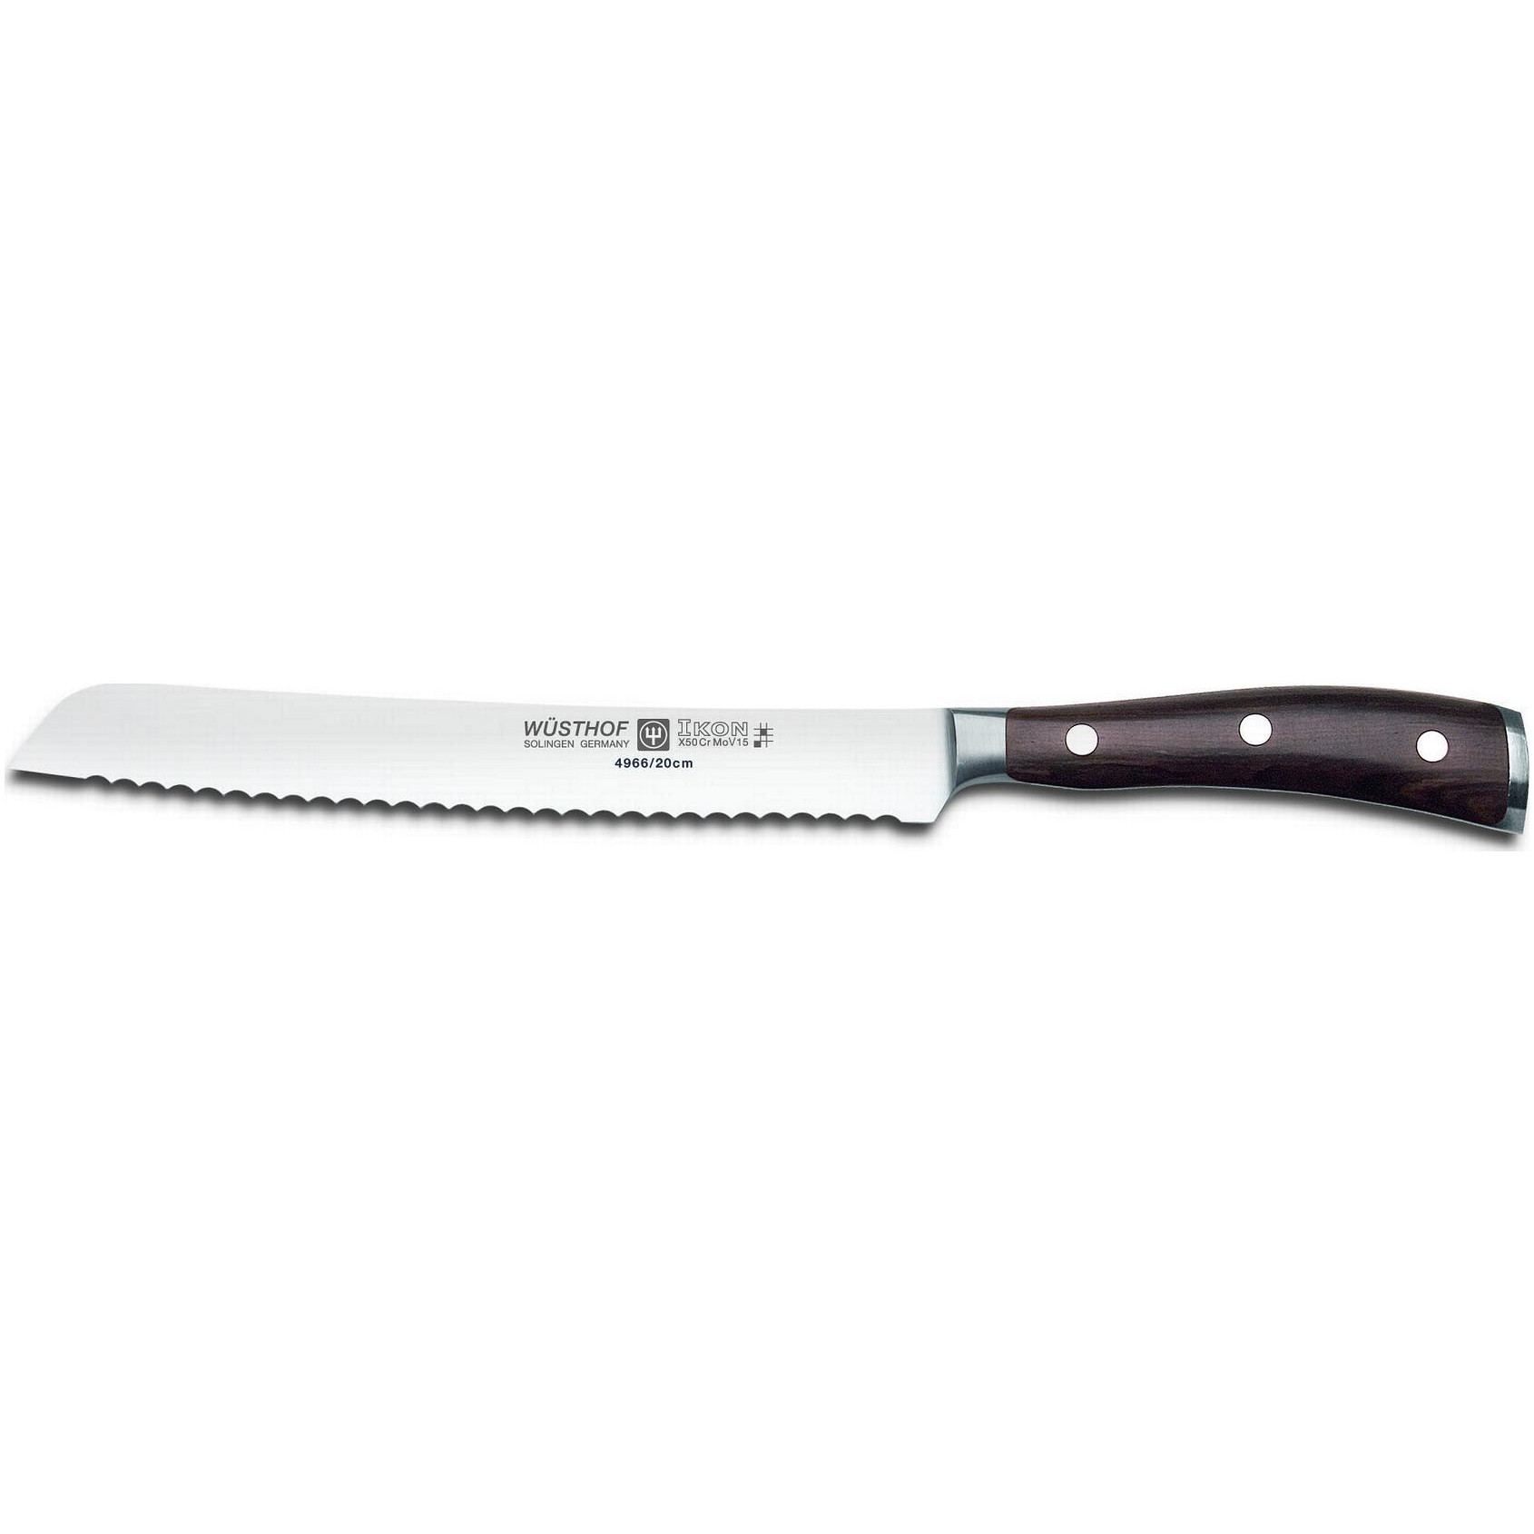
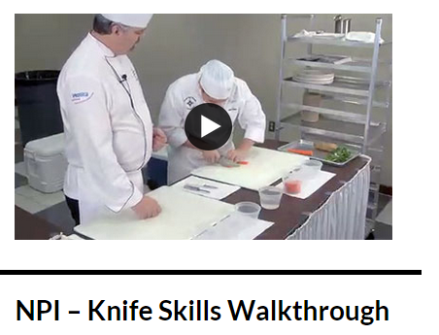
Part 3: Using www.GoProStart.com, click on Video link and then on the NPI-Knife Skills Walkthrough. For each cut, provide its definition and any tips that can help you be successful in class making the particular cut.
13 pt

Julienne (carrot) 2 pt

Brunoise (carrot) 2 pt

Medium Dice (potato) 2 pt

Diagonal (banana) 2 pt

What is the purpose of the acid bath for the banana? What other ingredients might need this? 1 pt.

Chiffonade (basil or spinach) 2 pt

Mince (parsley) 2 pt

