Healthy Preschooler Meals Cookbook
You are responsible for creating one page for our class cookbook for meals for preschoolers. You will demonstrate your knowledge of preschool nutrition through the creation of your meal that will specifically appeal to preschoolers. Since preschoolers are known as picky eaters, you want to make sure you follow the guidelines to creating meals with preschool appeal. Your meal should have realistic portion sizes for a preschooler (breakfasts, lunches and dinners should meet 1/3rd -1/2 of a preschoolers nutritional needs, snacks can meet 1/4th or less).
You will be assigned a meal by Ms. Jarvis, Circle it here: Breakfast Snack Lunch/Dinner

You must name your UNIQUE meal (do not go on pinterest for ideas, you must come up with it yourself!) you must include a picture of the food on the plate along with the serving sizes of the foods, their preparation methods, describe what % of their daily nutritional needs that your meal meets and explain to parents why your meal will be appealing to preschoolers. I have provided an example of what your page might look like below:
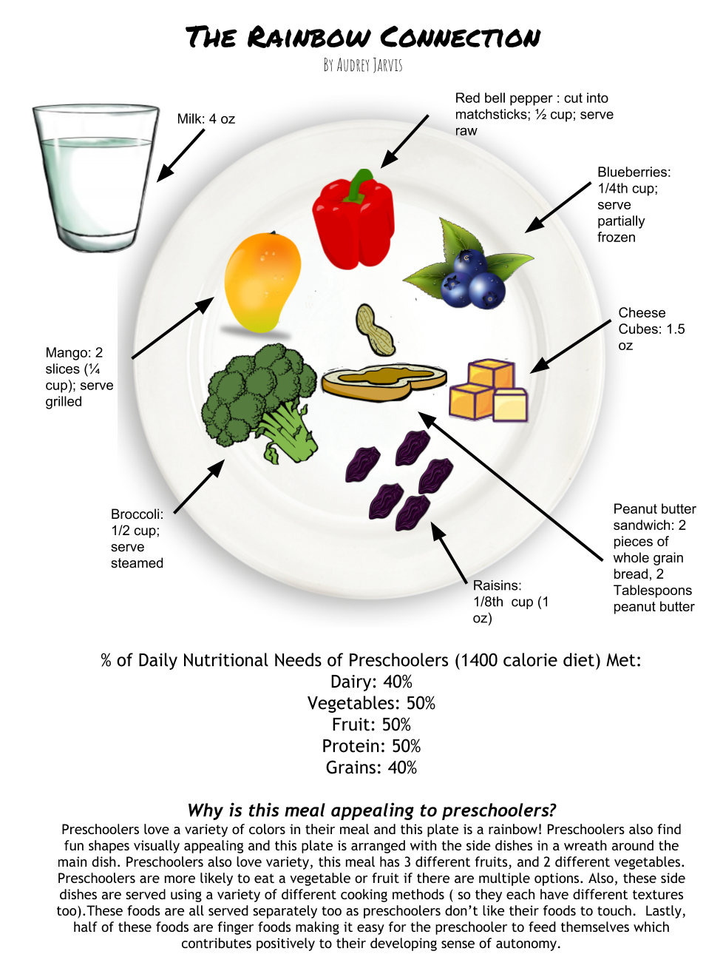
This project is worth points.
Food pictures with serving sizes & preparation methods: __________/10
% of daily nutritional needs of preschoolers identified:____________/10
Explanation as to why the meal is appealing to preschoolers:_________/10

