Lacing Cards: Fine Motor Skill Development in Preschoolers
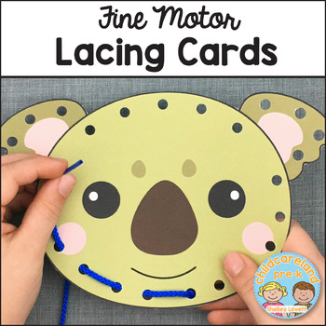
Design your own lacing card for preschoolers that we will bring to PLECC for the children to use to promote their fine motor skill development. You will draw (or use construction paper to construct) your own lacing card; it can be anything you like that you think will appeal to children! After that is designed, we will laminate them, then you can punch the holes out, pick out a yarn, attach the yarn to the starting hole and put some tape around the tip of the yarn to make it easier for the kids to fit it into the holes.
Have fun!

Lacing Cards: Fine Motor Skill Development in Preschoolers
Design your own lacing card for preschoolers that we will bring to PLECC for the children to use to promote their fine motor skill development. You will draw (or use construction paper to construct) your own lacing card; it can be anything you like that you think will appeal to children! After that is designed, we will laminate them, then you can punch the holes out, pick out a yarn, attach the yarn to the starting hole and put some tape around the tip of the yarn to make it easier for the kids to fit it into the holes.
Have fun!

Lacing Cards: Fine Motor Skill Development in Preschoolers
Design your own lacing card for preschoolers that we will bring to PLECC for the children to use to promote their fine motor skill development. You will draw (or use construction paper to construct) your own lacing card; it can be anything you like that you think will appeal to children! After that is designed, we will laminate them, then you can punch the holes out, pick out a yarn, attach the yarn to the starting hole and put some tape around the tip of the yarn to make it easier for the kids to fit it into the holes.
Have fun!

